**Air Quality of Dhaka City**

***Group 4***

***Author:***

***1. Meharab Hossen***

***Department of Computer Science and Engineering***

***University of Liberal Arts Bangladesh***

***2. Rifat Sarkar***

***Department of Computer Science and Engineering***

***University of Liberal Arts Bangladesh***

***3. Syeda Labiba Shams Mahamood***

***Department of Electrical and Electronic Engineering***

***University of liberal Arts Bangladesh***

***Introduction:***

Dhaka is the 4th large population city in the world**.** Dhaka, the capital city of Bangladesh has an area of 306.4 km2, one of the most densely populated cities in the world is prone to high ambient air pollution due to smoke generating brick kilns, vehicle and traffic exhaust on fuel with an elevated level of sulfur and re-suspended dust from roads dues. The effects of the uncontrolled population growth pressurize on the environment along with unrestrained urban development, subsequent fast industrialization, and automobile traffic has created huge ambient air pollution in this megacity

*So we work this project and find out the main issues of air pollution we know air have CO2, O2 and many other gas those gas have maximum rate and minimum rate to pollution air. We also work those gases and what will be the effect of this effect on human absorption .How to avoid it and make a good city. We also follow the good air quality city.*

**Project plan**

D

**Article Review**

**Title**

1.

How air quality and COVID-19 transmission change under different

lockdown scenarios? A case from Dhaka City, Bangladesh

Review: This article discusses air quality in covid-19 situation. In this study, we applied ground- and satellite-based data of five criteria air pollutants (PM2.5, NO 2 , SO 2 , O 3 , and CO) and meteorological factors from March 8 to May 15, 2020.  The generalized additive models wavelet coherence, and random forest model were employed to explore the relationship between air quality indicators and COVID-19 transmission in Dhaka city. . The implementation of a lockdown policy for containing COVID-19 transmission played a crucial role in reducing air pollution.  The discussion here could elucidate the effectiveness of lockdown scenarios for COVID-19 containment and air pollution control in Dhaka city. [1]

2

AMBIENT AIR QUALITY SCENARIO IN AND AROUND

DHAKA CITY OF BANGLADESH

Review: In this article, Air quality problems in Dhaka city scenario, such as infrastructure, coupled with the rapid growth in transportation. Air pollution is a pressing issue in our country as Bangladesh ranks 169th (out of 178 countries) on the Environmental Performance Index for Air Quality (APT, 2016). The main sources of air pollution include emissions from faulty vehicles, especially diesel- run vehicles, brick kilns and dust from roads and construction sites, and toxic fumes from industries. Here, the past and present scenarios of air pollution and ambient air quality in and around Dhaka city and the existing relevant air pollution controlling strategies, policies, laws, standards, and regulations in Bangladesh have been reviewed thoroughly.[2]

3.

Spatial and Temporal Trends of Air Quality around

Dhaka City: A GIS Approach

Review: In this article, The air quality index (AQI), is a comprehensive index that covers and integrates pollutants simultaneously and can reflect the comprehensive status of ambient air quality. It can investigate the spatial and temporal variation of air quality in Dhaka City, Bangladesh. With the help of AQI, one can limit one’s activity outdoors if one can, and if one must be outside, do so late in the day or early in the morning when air pollution levels are at their lowest. GIS map would also be useful for Residents to make an assessment according to the air quality index for that particular area, especially for the residents with respiratory disorders who can select a safer place to reside. . Finally, Understanding the air quality index is important because it would keep us informed about how to protect our health from air pollution.[3]

4

Environmental Overview of Air Quality Index

(AQI) in Bangladesh: Characteristics and

Challenges in the Present Era

Review: This article discusses the environmental overview of Air quality. The air quality of Bangladesh is the worst in the world and Dhaka ranks second among the polluted. The world is putting its best minds and resources into understanding and solving the air pollution problem, and so should we, as we have a long way to go than the others. The presents a clear scenario of air pollution conditions in and around Dhaka, Bangladesh from past to present. To this point, some important air pollution epidemiology studies should be conducted in Bangladesh to investigate the effects of air pollution on human health by our Govt. to revise the air quality standards to maximize their public health benefits. It’s high time to take immediate action and programs in our country for controlling air pollution.

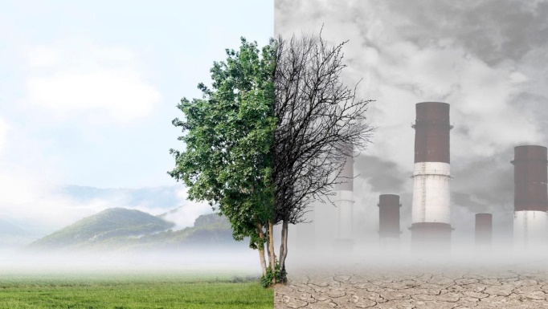

[4]

5

Key issues in controlling air pollutants in

Dhaka, Bangladesh

Review:

In this article, Dhaka is densely populated and with the increase in economic development, the air quality has deteriorated for many practical reasons. As a result people living in Dhaka city facing respiratory disease, especially in wintertime. The major sources of fine particulate pollution are identified as the emissions from vehicles and brick kilns around Dhaka city. The Government of Bangladesh is trying to improve air quality through reductions in emissions from motor vehicles by conversion. During the last few decades, positive industrialization and urbanization trends have contributed to the significant population increase and economic development in Dhaka city.

Key issues in controlling air pollutants in

Dhaka, Bangladesh

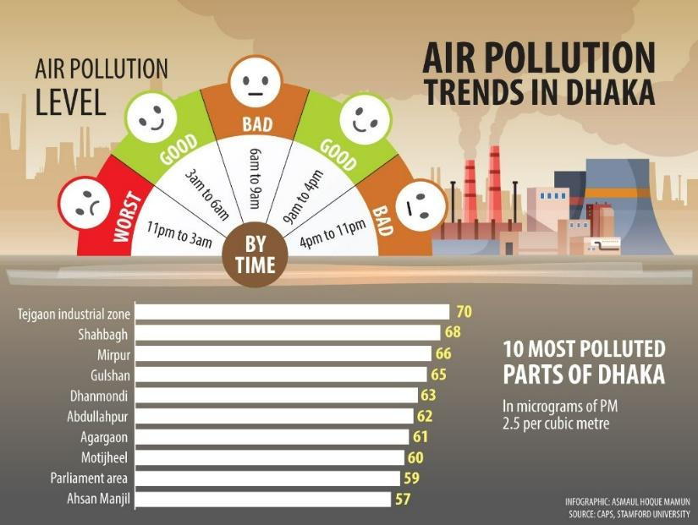

[5]

6

**Why is Dhaka endangered being the major risks of highly polluted cities in the world?**

Dhaka the capital of Bangladesh formerly known as 'Dacca ' popularly  known for its  Islamic architectures as the city of mosques.The Capital earns its  recognition for being the most populous  city in Bangladesh and definitely stands a  higher position  in one of the most polluted in the world rankings.The reasons for the highly populated and polluted capital is  more the massive amounts of  smoke ,smog produced by the huge vehicles, cars motorcycles etc. Damaging the air causes the high chances of Global warming.The toxic air mixtures of black carbon ,methane Chemical compounds such as nitrogen dioxide (NO2) and sulfur dioxide (SO2) would also be abundant in the atmosphere, once again finding their creation from both cars and factories alike. The brick kilns would produce vast amounts of their own smoke and haze, containing other compounds such as carbon monoxide (CO) and

the pollution levels start to show considerable rises in the month of October, coinciding with the end of monsoon season and as such lacking the necessary rain that is always helpful in cleaning a cities air and washing away its fine dust particles.September saw a PM2.5 reading of 37.7 μg/m³ in 2019. This jumped up significantly in October to 64.6 μg/m³, and increase of nearly twofold. These numbers continued to rise until they hit their absolute peak in January, with a reading of 181.8 μg/m³ being present. [6]

7.

Reasons why the air in Dhaka is Highly Contagious?

The amount of toxic air particles, mixture of  gasses, the burning  of fossil  fuels and methane which causes air poisoning so with air pollution levels this  contagious, the preventative measures become vital for Dhaka's citizens, with the avoidance of outdoor activities as well as the wearing of fine particle filtering masks being highly necessary. After the peak in January, pollution levels still remained extremely high but showed a steady drop, with a reading of 145.7 μg/m³ in February, followed by 107.4 μg/m³ in March. These numbers continued to drop until reaching the cleanest months of the year, June through to September, with August coming in with the cleanest reading of the year at 31.3 μg/m³.[7]

8.

How air quality and COVID-19 transmission change under different lockdown scenarios? A case from Dhaka city, Bangladesh?

In this Article we came across how the lockdown took over the air quality of  Dhaka  and the drastic changes as with The lockdown policy triggered a sudden reduction of air pollution in Dhaka city comparatively to the past years.The generalized additive models (GAMs), wavelet coherence, and random forest (RF) model were employed to explore the relationship between air quality indicators and COVID-19 transmission in Dhaka city. Results show that overall, 26, 20.4, 17.5, 9.7 and 8.8% declined in PM 2.5, NO2, SO2, O3, and CO concentrations, respectively, in Dhaka City during the partial and full lockdown compared to the period before the lockdown.[8]

9.

Ambient Air Quality in Dhaka

Bangladesh over Two Decades: Impacts

Of Policy on Air Quality Review: This article author discusses about recent air quality this article based on air quality data . This article author was create a long term process to improve and he shows many ways to air quality of Dhaka city there are Mapping Dhaka city ,grapes and

find out to gas quality of air . These auricle

main keywords are: PM 10 ; PM 2.5 ; Black carbon

(BC); Lead (Pub); Long-term monitoring.

This grapes I saw many flat no mentions to long

term process and not give 2 nd plan to improve this air quality This Article good point is it is database project and this data is raw and find out main problem in air

quality .

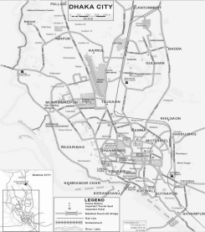

[9]

10.

# Monitoring Air Quality of Dhaka using IoT: Effects of COVID-19

This article first of all discuss about Dhaka city population and  position of air quality in the world ranking then they discuss how to  create this article they use this  many section  .section  2 they give a  flowchart  then the work this pandemic  years a softener  and then they  find data and realize  to main point. But they not compare air quality previous years so it is so bad thing in this article also there collecting data is not real it’s based on softener.

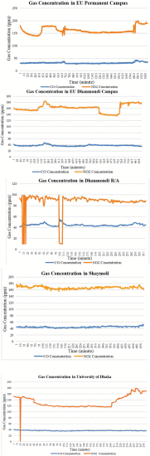

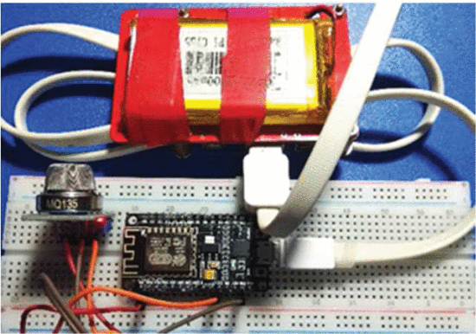

[10]

References:

1.

Md. Siddiqur Rahman  a   1 , Md. Abul Kalam Azad  a   1 How air quality and COVID-19 transmission change under different

lockdown scenarios? A case from Dhaka City, Bangladesh, Air Quality Research, (2020)

2.

Begum, B. A. and S. K. Biswas. 2008. Trends in particulate matter (PM) and lead pollution in ambient air of Dhaka

city in Bangladesh. Journal of Bangladesh Academy of Sciences. 32 (2): 209-217.

3. Koas AL, Ahmad K (2010) GIS-based mapping and statistical analysis of air pollution and mortality in Doctoral dissertation,

Queensland University of Technology, Brisbane, Australia.

4.

Ahmed H.U. (2020), ‘Stuck in air pollution and traffic congestion’ [Internet], The Financial Express, Dhaka, February 28,Available from:https://thefinancialexpress.com.bd/views/stuck-in-air-pollution-and- traffic-congestion-1582903193

5.

B.A. Begum Investigation of sources of atmospheric aerosol at urban and semi-urban areas in Bangladesh,

Atmospheric Environment. (2004)

6.

<https://www.iqair.com/bangladesh/dhaka>

7. <https://www.tbsnews.net/environment/air-quality-dhaka-lessons-covid-19-shutdown>

8. <https://www.sciencedirect.com/science/article/pii/S0048969720366912>

9. BA Begum, [PK Hopke](https://scholar.google.com/citations?user=lFuICO4AAAAJ&hl=en&oi=sra) ,***Ambient Air Quality in Dhaka Bangladesh over Two Decades: Impacts of Policy* on Air Quality ,** Aerosol and Air Quality Research, (2018)

10. [Rajib Saha](https://ieeexplore.ieee.org/author/37088659604); [S N M Azizul Hoque](https://ieeexplore.ieee.org/author/37088659609); [M M R Manu](https://ieeexplore.ieee.org/author/37088657828); [Aminul Hoque](https://ieeexplore.ieee.org/author/37088658785)  (2021), ***Ambient Air Quality in Dhaka Bangladesh over Two Decades: Impacts of Policy* on Air Quality, IEEE**